Lab 1: Create a new database named school_db and a table called students with the following columns: student_id, student_name, age, class, and address.

create database student_data;

CREATE TABLE student (student_id INT PRIMARY KEY,student_name VARCHAR(20),student_age INT,student_address VARCHAR(50),student_class INT)

select * from student_int;

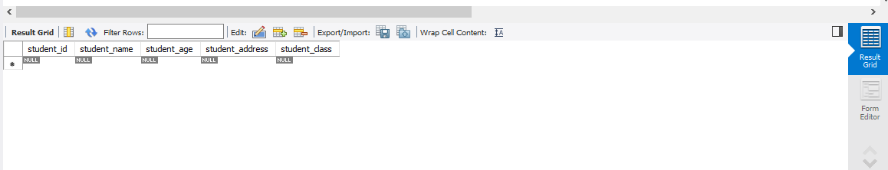

• Lab 2: Insert five records into the students table and retrieve all records using the SELECT statement.

create table abc (student_id int primary key, student_name varchar(20), student_email_id varchar(20), student_phone_number int, student_address varchar(50), student_age int, student_class varchar(10));

INSERT INTO abc (student_id, student_name, student_email_id, student_phone_number, student_address, student_age, student_class) VALUES (101, 'Ibrahim', 'Ibrahim@gmail.com', 1233464, 'Zampa, Surat', 20, 12);

INSERT INTO abc (student_id, student_name, student_email_id, student_phone_number, student_address, student_age, student_class) VALUES (102, 'Huzaifa', 'Huzaifa@gmail.com', 123323464, 'Vesu, Surat', 23, 12);

INSERT INTO abc (student_id, student_name, student_email_id, student_phone_number, student_address, student_age, student_class) VALUES (103, 'Taher', 'Taher@gmail.com', 123342344, 'Bhagal, Surat', 21, 12);

INSERT INTO abc (student_id, student_name, student_email_id, student_phone_number, student_address, student_age, student_class) VALUES (104, 'Mufaddal', 'mufaddal@gmail.com', 1223433464, 'ustampura, Surat', 20, 12);

INSERT INTO abc (student_id, student_name, student_email_id, student_phone_number, student_address, student_age, student_class) VALUES (105, 'Ibrahim', 'Ibrahim@gmail.com', 1233462344, 'Zampa, Surat', 20, 12);

select *from abc;

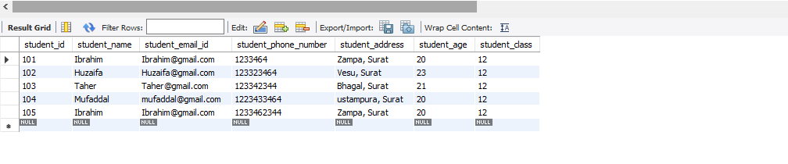

2. SQL Syntax

• Lab 1: Write SQL queries to retrieve specific columns (student_name and age) from the students table

SELECT student_name, student_age FROM student_int;

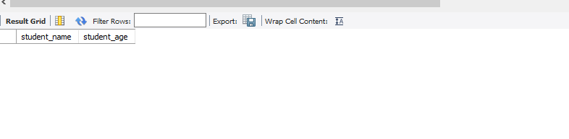

• Lab 2: Write SQL queries to retrieve all students whose age is greater than 10.

SELECT student_age FROM student_int WHERE student_age > 10;

3. SQL Constraints

Lab 1: Create a table teachers with the following columns: teacher_id (Primary Key), teacher_name (NOT NULL), subject (NOT NULL), and email (UNIQUE).

CREATE TABLE student_int (

student_id INT PRIMARY KEY,

student_name VARCHAR(20),

student_age INT,

student_address VARCHAR(50),

student_class INT,

teacher_id INT,

FOREIGN KEY (teacher_id) REFERENCES teacher_data(teacher_id)

);

create table teacher (teacher_id int primary key,teacher_name varchar(10) not null,teacher_subject varchar (20) not null,teacher_email_id varchar(20) unique);

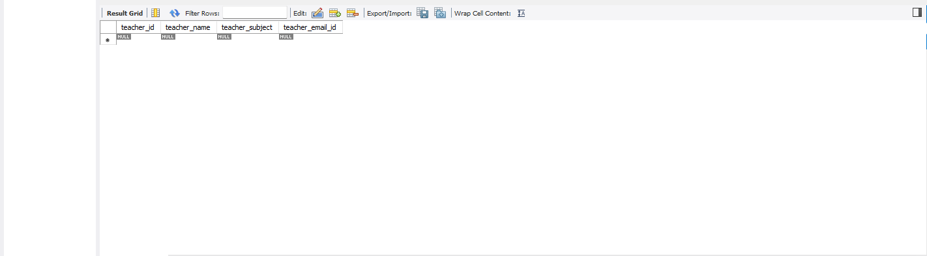

4. Main SQL Commands and Sub-commands (DDL)

Lab 1: Create a table courses with columns: course_id, course_name, and course_credits. Set the course_id as the primary key.

create database student_ata;

create database university_dB;

use student_ata;

create table courses(

course_id int primary key,

course_name varchar (20),

course_credits varchar(20)

);

select * from courses;

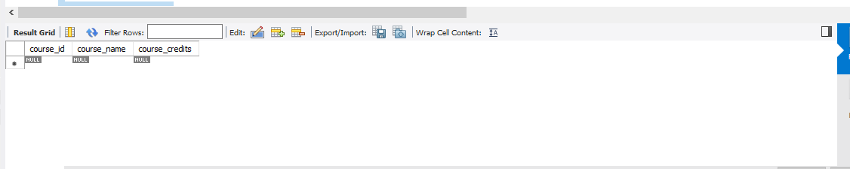

• Lab 2: Use the CREATE command to create a database university_db.

create database university_db;

use university_db;

5. ALTER Command

Lab 1: Modify the courses table by adding a column course_duration using the ALTER command

select * from courses;

ALTER TABLE courses ADD COLUMN course_duration VARCHAR(50);

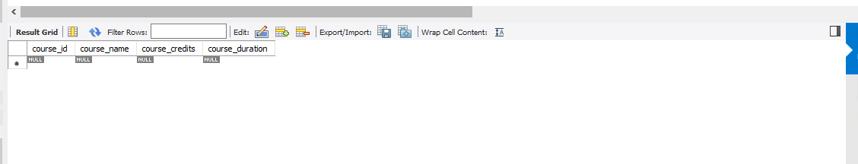

Lab 2: Drop the course_credits column from the courses table.

ALTER TABLE courses DROP COLUMN course_credits;

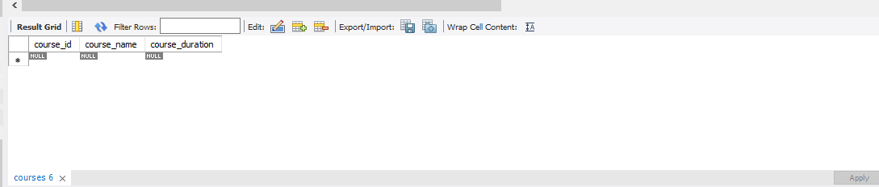

6. DROP Command

Lab 1: Drop the teachers table from the school_db database.

drop table teacher_data;

Lab 2: Drop the students table from the school_db database and verify that the table has been removed.

show tables;

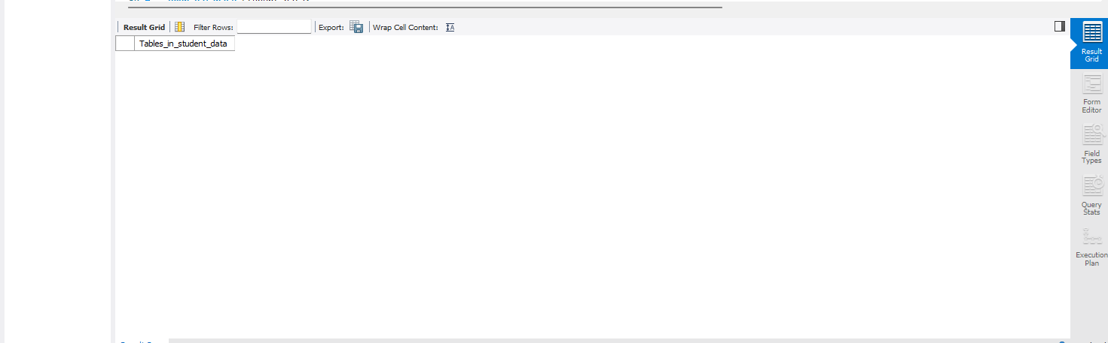

7. Data Manipulation Language (DML)

Lab 1: Insert two records into the courses table using the INSERT command

INSERT INTO courses(course_id,course_name,course_credits) values

('1','html','2'),

('2','css','3');

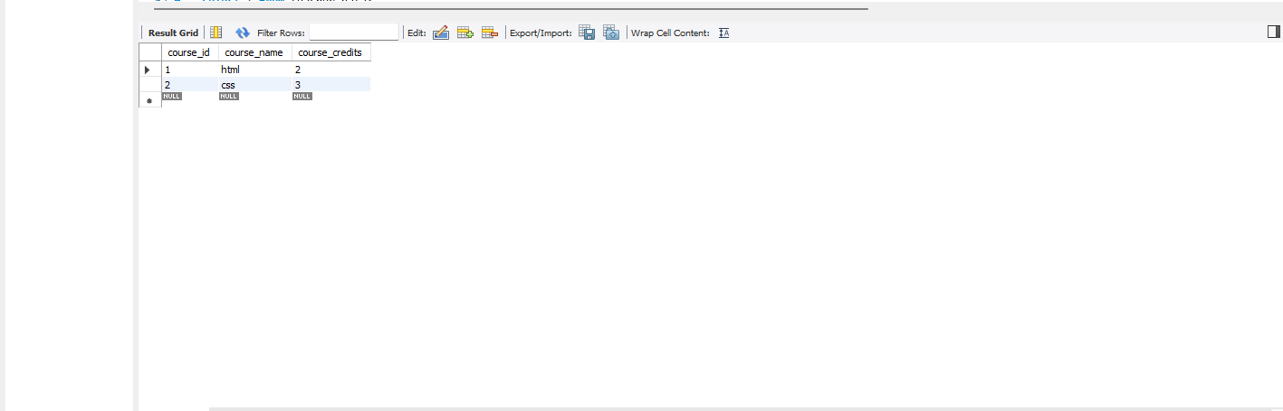

Lab 2: Update the course duration of a specific course using the UPDATE command

UPDATE courses SET course_duration = '3 months ‘WHERE course_id = 1;

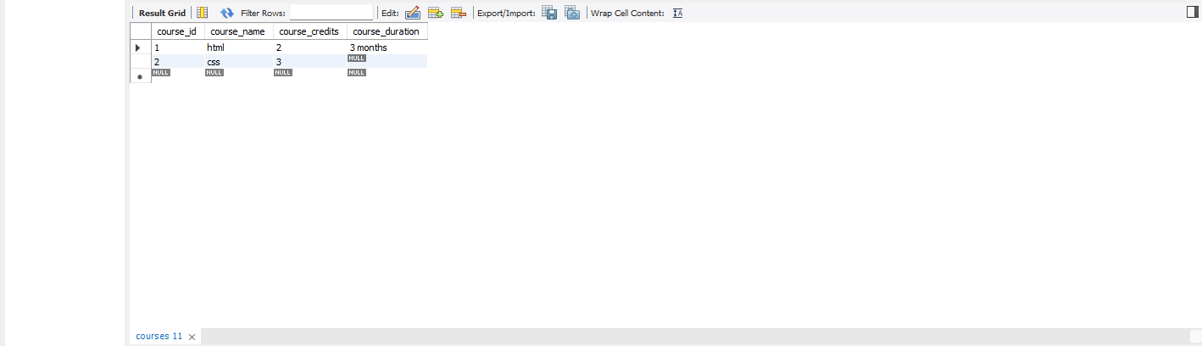

• Lab 3: Delete a course with a specific course_id from the courses table using the DELETE command.

DELETE FROM courses WHERE course_id = 1;

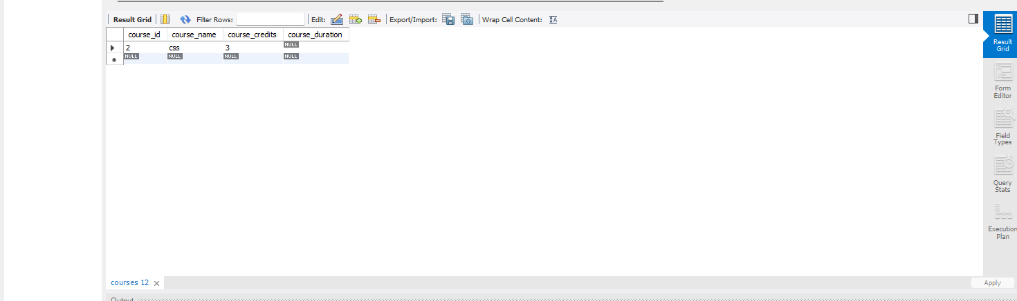

8. Data Query Language (DQL)

• Lab 1: Retrieve all courses from the courses table using the SELECT statement

Select * from course

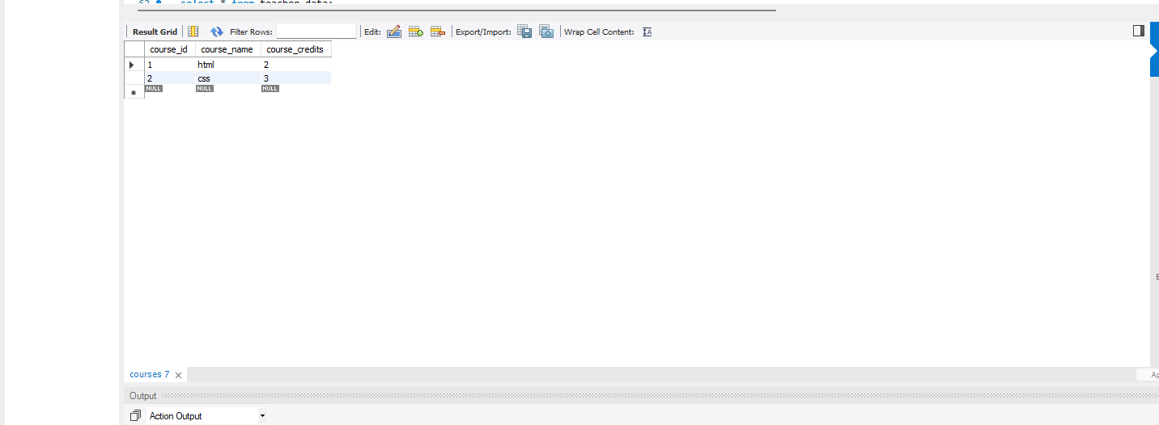

Lab 2: Sort the courses based on course_duration in descending order using ORDER BY.

SELECT * FROM courses ORDER BY course_duration DESC;

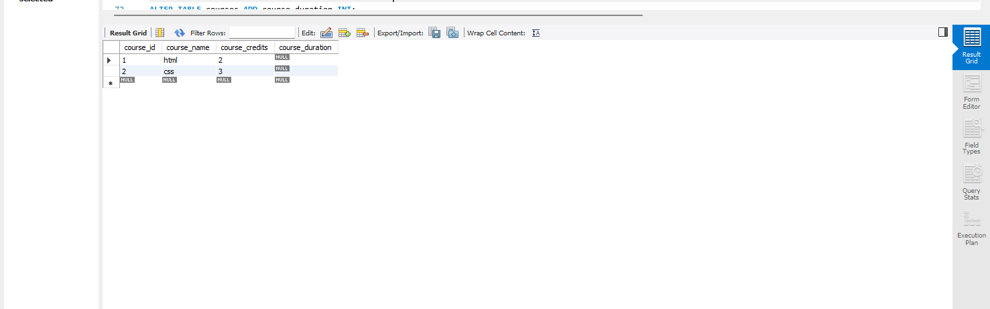

Lab 3: Limit the results of the SELECT query to show only the top two courses using LIMIT.

SELECT * FROM courses ORDER BY course_duration DESC

LIMIT 2;



9. Data Control Language (DCL)

• Lab 1: Create two new users user1 and user2 and grant user1 permission to SELECT from the courses table

CREATE USER 'user2'@'localhost' IDENTIFIED BY 'password2';

DROP USER IF EXISTS 'user2'@'localhost';

CREATE USER 'user2'@'localhost' IDENTIFIED BY 'password2';

SELECT user, host FROM mysql.user;

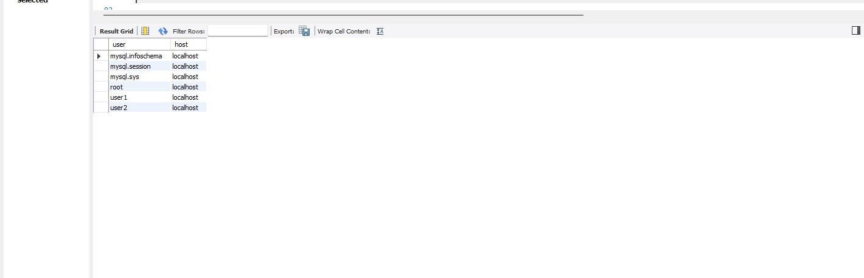

• Lab 2: Revoke the INSERT permission from user1 and give it to user2.

REVOKE INSERT ON student_data.courses FROM 'user1'@'localhost';

GRANT INSERT ON student_data.courses TO 'user2'@'localhost';

SHOW GRANTS FOR 'user1'@'localhost';

SHOW GRANTS FOR 'user2'@'localhost';

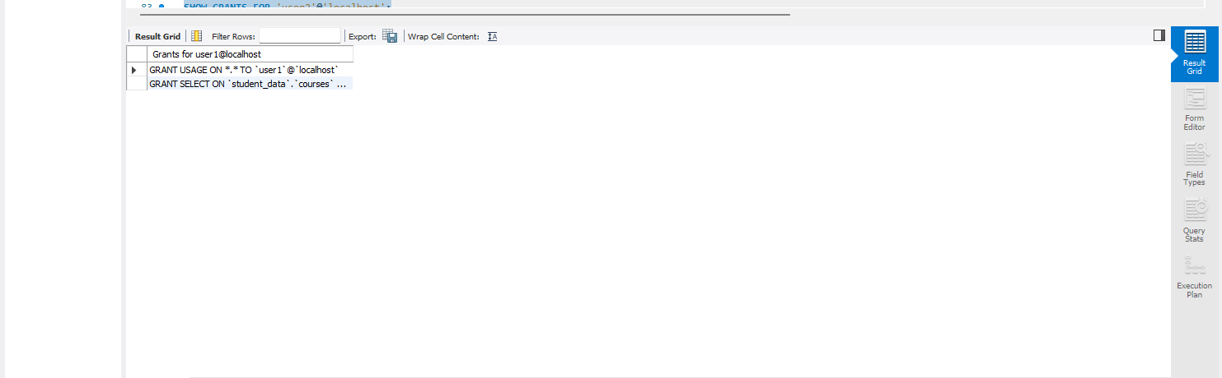

10. Transaction Control Language (TCL)

• Lab 1: Insert a few rows into the courses table and use COMMIT to save the changes.

START TRANSACTION;

INSERT INTO courses (course_id, course_name, course_duration, course_fee)

VALUES

(1, 'Python Programming', 6, 5000),

(2, 'Web Development', 8, 6000),

(3, 'Data Science', 10, 8000);

commit;

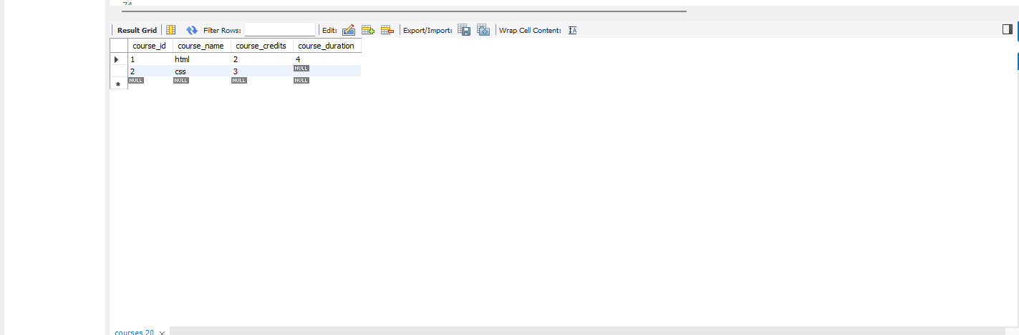

• Lab 2: Insert additional rows, then use ROLLBACK to undo the last insert operation.

START TRANSACTION;

INSERT INTO courses (course_id, course_name, course_duration)

VALUES

(4, 'Machine Learning', 12),

(5, 'Cybersecurity', 10);

ROLLBACK;

SELECT * FROM courses;

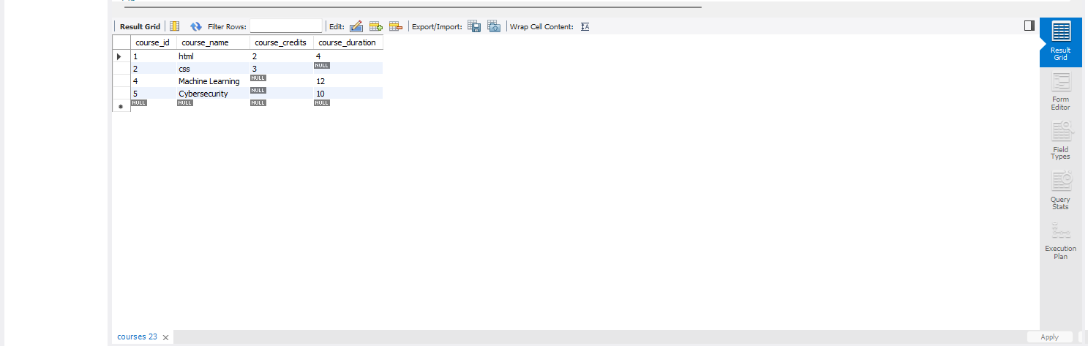

Lab 3: Create a SAVEPOINT before updating the courses table, and use it to roll back specific changes.

START TRANSACTION;

SAVEPOINT before_update;

UPDATE courses

SET course_duration = 14

WHERE course_id = 2;

UPDATE courses

SET course_duration = 16

WHERE course_id = 3;

ROLLBACK TO SAVEPOINT before_update;

COMMIT;

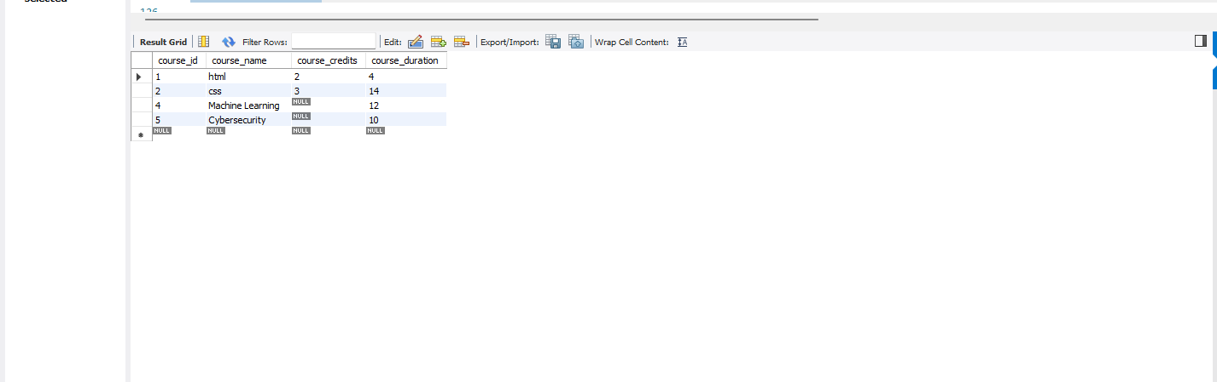

11. SQL Joins

Lab 1: Create two tables: departments and employees. Perform an INNER JOIN to display employees along with their respective departments

SELECT

e.Employee_id,

e.Employee_First_name,

d.Department_name

FROM

employee e

INNER JOIN

Depatment1 d ON e.Department_id = d.Department_id;

• Lab 2: Use a LEFT JOIN to show all departments, even those without employees.

SELECT

d.Department_id,

d.Department_name,

e.Employee_id,

e.Employee_First_name

FROM

Depatment1 d

LEFT JOIN

employee e ON d.Department_id = e.Department_id;

12. SQL Group By

Lab 1: Group employees by department and count the number of employees in each department using GROUP BY.

SELECT

d.Department_id,

d.Department_name,

COUNT(e.Employee_id) AS employee_count

FROM

Depatment1 d

LEFT JOIN

employee e ON d.Department_id = e.Department_id

GROUP BY

d.Department_id, d.Department_name;

Lab 2: Use the AVG aggregate function to find the average salary of employees in each department.

SELECT

d.Department_id,

d.Department_name,

AVG(e.Employee_salary) AS average_salary

FROM

Depatment1 d

LEFT JOIN

employee e ON d.Department_id = e.Department_id

GROUP BY

d.Department_id, d.Department_name;

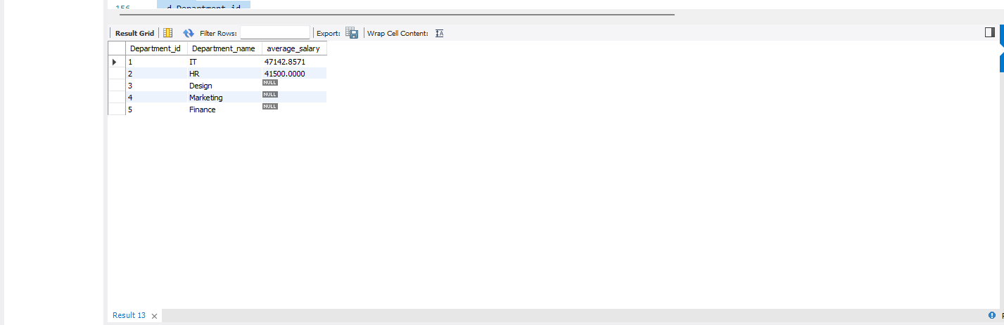

13. SQL Stored Procedure

Lab 1: Write a stored procedure to retrieve all employees from the employees table based on department

DELIMITER $$

CREATE PROCEDURE getemid(IN emp_id INT)

BEGIN

SELECT * FROM employee WHERE Employee_id = emp_id;

END$$

DELIMITER ;

CALL getemid(1);

Lab 2: Write a stored procedure that accepts course_id as input and returns the course details.

DELIMITER $$

CREATE PROCEDURE getCourseDetails (

IN input_course_id INT

)

BEGIN

SELECT *

FROM courses

WHERE course_id = input_course_id;

END$$

DELIMITER ;

CALL getCourseDetails(1);

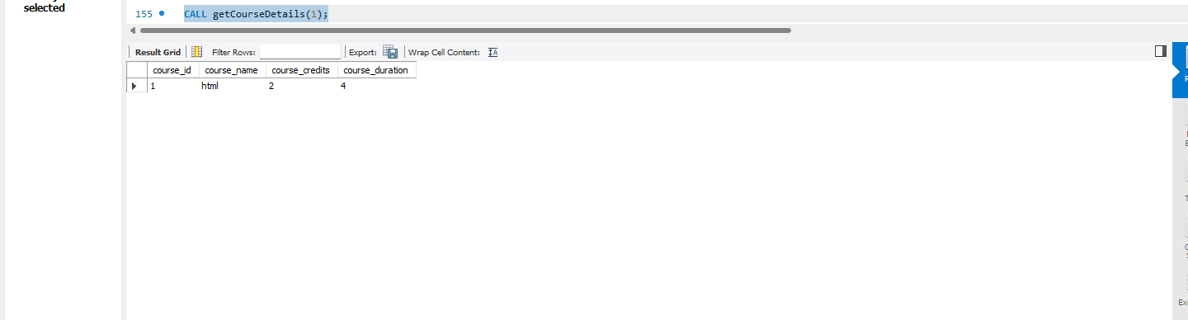

14. SQL View

• Lab 1: Create a view to show all employees along with their department names

CREATE VIEW employee_with_Depatment1 AS

SELECT

e.Employee_id,

e.Employee_First_name,

e.Employee_last_name,

e.Employee_position,

e.Employee_salary,

e.Department_id,

d.Department_name

FROM

employee e

JOIN

Depatment1 d ON e.Department_id = d.Department_id;

SELECT * FROM employee_with_Depatment1;

• Lab 2: Modify the view to exclude employees whose salaries are below 50,000.

CREATE VIEW employee_with_department_view AS

SELECT

e.Employee_id,

e.Employee_First_name,

e.Employee_last_name,

e.Employee_position,

e.Employee_salary,

e.Department_id,

d.Department_name

FROM

employee e

JOIN

Depatment1 d ON e.Department_id = d.Department_id

WHERE

e.Employee_salary >= 50000;

SELECT * FROM employee_with_department_view;

15. SQL Triggers

Lab 1: Create a trigger to automatically log changes to the employees table when a new employee is added.

create table temp(

tid int primary key auto_increment,

empid int,

time_of_event datetime,

event_name varchar(30)

);

create trigger trimp after update on employee for each row

insert into temp(empid,time_of_event,event_name)values

(old.Employee_id,now(),"update");

UPDATE employee SET Employee_First_name = '' WHERE Employee_id = 1;

select * from temp;

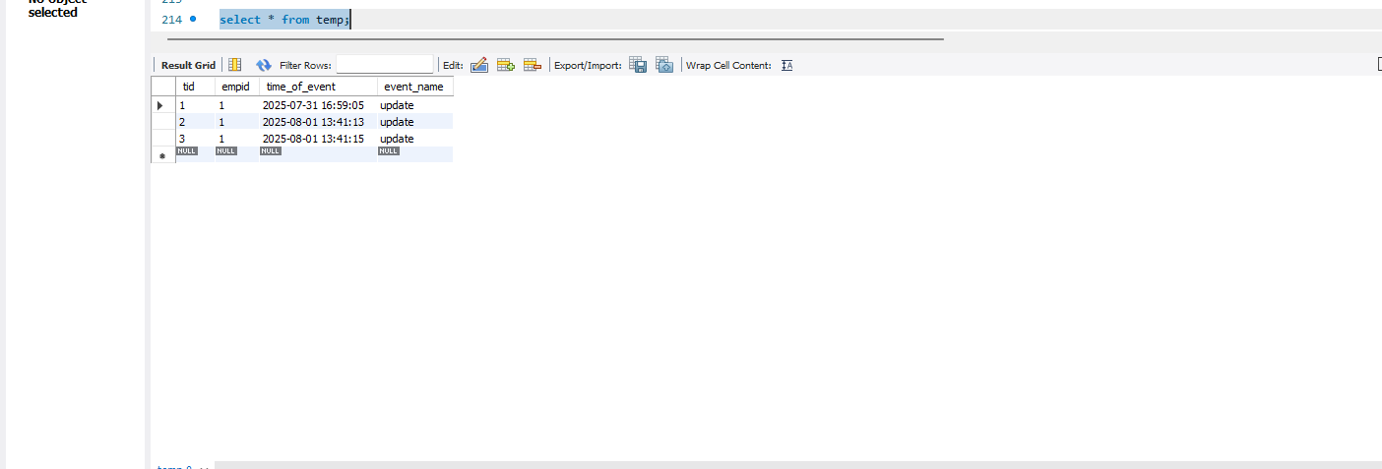

Lab 2: Create a trigger to update the last_modified timestamp whenever an employee record is updated.

ALTER TABLE employee

ADD COLUMN last_modified TIMESTAMP DEFAULT CURRENT_TIMESTAMP

ON UPDATE CURRENT_TIMESTAMP

DELIMITER $$

CREATE TRIGGER before_employee_update

BEFORE UPDATE ON employee

FOR EACH ROW

BEGIN

SET NEW.last_modified = CURRENT_TIMESTAMP;

END$$

DELIMITER ;

;

UPDATE employee

SET Employee_salary = 70000

WHERE Employee_id = 101;

SELECT Employee_id, last_modified FROM employee WHERE Employee_id = 1;

